**Excel Assignment – 7**

**1. Using Insert Function, give examples of any function available in the different dropdowns present in the function library. For example AutoSum, Recently Used, Text, Date & Time, etc**.

MS Excel has many inbuilt in functions that we can use in our formula. If you want to see all the functions by category choose Formulas Tab and then Insert Function. Then Insert function Dialog appears from which we can choose function.

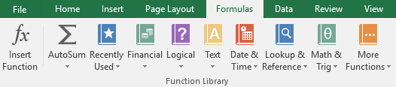

**Text Functions**

Lower: Converts all characters in a given text string to lowercase.

UPPER: Converts all characters in a given text string to uppercase

CONCATENATE: It will join together two or more text strings

LEFT: It will return a specified number of characters from the beginning of a supplied text string

RIGHT: Returns a specified number of characters from the end of a supplied text

**Logical**

AND: Tests a number of user-defined conditions and returns TRUE if ALL of the conditions evaluate to TRUE, or FALSE otherwise

OR: Tests a number of user-defined conditions and returns TRUE if ANY of the conditions evaluate to TRUE, or FALSE otherwise

NOT: It will return a logical value that is the opposite of a user given logical value or expression i.e. returns FALSE is the given argument is TRUE and returns TRUE if the given argument is FALSE)

**2. What are the different ways you can select columns and rows?**

You can also click anywhere in the table column, and then press CTRL+SPACEBAR, or you can click the first cell in the table column, and then press CTRL+SHIFT+DOWN ARROW. Note: Pressing CTRL+SPACEBAR once selects the table column data; pressing CTRL+SPACEBAR twice selects the entire table column.

**3. What is AutoFit and why do we use it?**

AutoFit is a feature in Excel that lets you easily change the size of one or multiple columns or rows on a spreadsheet. It helps you make sure that all the data in every cell group is clearly visible.

**4. How can you insert new rows and columns into the existing table?**

Click in a cell above or below where you want to add a row. Under Table Tools, on the Layout tab, do one of the following: To add a row above the cell, click Insert Above in the Rows and Columns group. To add a row below the cell, click Insert Below in the Rows and Columns group.

**5. How do you hide and unhide columns in excel?**

Hide or show rows or columns

* Select one or more columns, and then press Ctrl to select additional columns that aren't adjacent.
* Right-click the selected columns, and then select Hide.

**6. Create an appropriate table within the worksheet and use different**

**functions available in the AutoSum command.**

SUM

Type the equals sign (=), then enter the function name (SUM, for example).

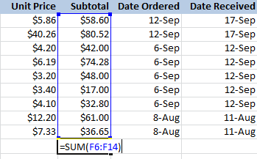

Press Enter, and the result will appear.

AVERAGE

* click the AutoSum drop-down arrow and select the function you want (Average, for example).
* 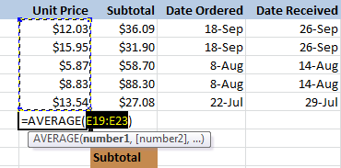
* Press **Enter**, and the result will appear.

COUNT

1. Enter the sample data on your worksheet
2. In cell A7, enter an COUNT formula, to count the numbers in column A:   **=COUNT(A1:A5)**

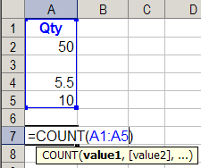

1. Press the Enter key, to complete the formula.
2. The result will be 3, the number of cells that contain numbers.

MIN

MIN formula in column D will find the lowest value in a range of cells, H2:H17

**=MIN(H2:H17)**

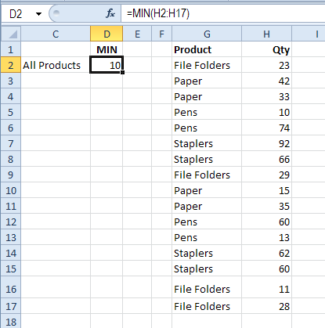

MAX

his formula will find the highest value in the range of cells, H2:H17

**=MAX(H2:H17)**

